producing another world

andrew pickering

university of exeter

a.r.pickering@exeter.ac.uk

‘Assembling Culture’ workshop, University of Melbourne, Australia, 10-11 December 2007.

•

[C]yborg politics insist on noise and advocate pollution, rejoicing in the illegitimate fusions of animal and machine.
Donna Haraway, A Manifesto for Cyborgs (2004, 34).

What are we going to retain from the moderns? Everything . . .
Bruno Latour, We Have Never Been Modern (1993, 132).

I want to address the very broad and broadly political question of what sort of culture we want to assemble, which entails, of course, asking what sort of culture we have now and what sorts of alternative one might imagine. My way into this problematic begins in science and technology studies.

STS has been a very fertile field over the past couple of decades, most radically perhaps in conjuring up new ontological visions, new sorts of pictures of what the world is like, what sorts of things there are in it and how they relate to one another. The theorists of the actor-network, Bruno Latour, Michel Callon, et al, led the way, with their image of a squirming morass of human and nonhuman hybrids morphing between the micro and the macro (Callon and Latour 1981). But sooner or later, the question had to come up: so what? Surely something should follow from these drastic ontological reconceptualisations. Having understood the world differently, something should follow for how we conduct our affairs in it.

Latour was again in the lead in addressing these questions—from his early thoughts on a Parliament of Things at the end of We Have Never Been Modern (1993) to his recent Politics of Nature: How to Bring the Sciences into Democracy (2004). But somewhere along the way from ontology to politics Latour’s writing lost its edge. Although he points to range of ecological crises as making a new ontological vision possible, he clearly thinks that ‘modernity’ as he defines it is basically OK and he wants to preserve as much of it as possible. This is, no doubt, why the Parliament of Things turns out to be a species of antifoundationalism-in-action. If no-one, not even natural scientists, is in possession of indubitable truths of nature—a fundamental lesson from STS—then we should all assemble together, on a level playing field—scientists, politicans, all the interested parties—to debate sociotechnical initiatives in an open-ended way, always ready to revise our positions in the light of unfolding experience, with none having the final say. Latour as Habermas.

Achieving this state of affairs sounds like a workable and important project, worthy of the EU. It would certainly slow down our headlong rush into potentially disastrous mega-projects, and this is Latour’s stated goal. And yet it leaves so much the same: ‘We have only to ratify what we have always done, provided that we reconsider our past . . .’ (Latour 1993, 144). Here I want to explore a different transit from ontology to politics.

•

We can start with a simple ontological contrast. Our pre-eminent natural science, physics, evokes a dualist split between people and things, simply by describing a world of things—quarks, say—existing completely independently of us. These things have fixed properties and relations that we can know, and—shifting from physics to engineering—through this knowledge we can predict and control their behaviour. The overall ontological vision here is thus an asymmetric dualism that echoes Descartes: the world is a knowable machine, while on the other side humanity calls the shots as the only source of genuine agency in the world.

But then comes the twist. The great discovery of science studies was that in practice the sciences themselves fail to exemplify this ontology. It turns out that in their own laboratories the scientists are far from calling all the shots. They do not dominate their materials through knowledge; instead they engage in rather symmetrical open-ended and performative dances of agency, trying this and that in their struggles with machines and instruments, finding out what the world will do in this circumstance or that, and responding to what emerges in a process that I call mangling (Pickering 1995).

So studies of scientific practice conjure up a new ontological vision, a quasi-biological one, of the world as itself as a lively place, itself a reservoir of agency, that can always surprise us in its performance, and that we always have to get along with and accommodate ourselves to, rather than seeing through and controlling. We are always, so to speak, in the thick of things.

What can we make of this pair of contrasting ontologies? We could say that science studies has learned to read the sciences against the grain, refusing to take their ontological vision for granted and coming up with another one in its place. Or, as I am inclined to do, we could say that in a remarkable historical process the sciences have learned to read nature against the grain, organising their still mangle-ish practice around a telos of making a clean split between a machine-like nature and humanity as controlling agents.

Latour has nothing but admiration for this telos which hangs together nicely with his idea that modernity is basically fine, and that the Parliament of Things just needs to organise this dualist teleology more democratically: ‘[T]he creation of stabilized objects independent of society, the freedom of a society liberated from objects—all these are features we want to keep’ (Latour 1993, 133). I want to go in a different direction.

My idea, very simply, is that put this way the ontological discussion points to a space of other ways to go on. Instead of continually struggling to impose this dualist telos on nature we could go with the flow—we could organise our lives in ways that thematise and take advantage of open-ended performative dances of agency instead of seeking to extinguish and efface them.

The remainder of this essay circles around this idea and associated issues. I give some examples of the sorts of projects I have in mind. Then I discuss the political valence of such projects. Finally I try to conjure up and address the moral abhorrence they elicit from Enlightenment thinkers like Latour.

My examples all derive from my historical research into the history of cybernetics in Britain. I have written them up at greater length elsewhere, so here I just offer minimal sketches of a few instances. In this essay, my primary goal is to clarify the overall drift of the argument.

•

We could begin in the most ethereal realm known to man or woman—mathematics. It is becoming more widely recognised that not only do scientific theories tend to conjure up the dualist ontology I just sketched out but so do the mathematical techniques that they drawn upon. The vast preponderance of our mathematical history has to do with rendering systems of abstract entities transparent, calculable, soluble, predictable—the Laplacean fantasy of knowing the future given the present, of the world as never being able to surprise us if only we could learn to do the sums properly. But there is growing recognition is that this fantasy is a fantasy, that the world isn’t like that at all, and what interests me here is that this realisation is not at all incapacitating; that there are other ways to go on, even in mathematics. So my first example is work on mathematical systems called cellular automata, CAs, largely developed by Stephen Wolfram (Wolfram 2002, Pickering forthcoming a).

A CA is a set of zeroes and ones defined at points on a line, and these values evolve in a series of time-steps according to some simple rule having to do with the previous value assigned at each point and its neighbours. Wolfram’s great discovery is, as he puts it, that extremely simple rules can generate extremely complex behaviour. While some rules generate entirely predictable patterns in time, others are ‘computationally irreducible,’ meaning that the only way to know what pattern they will generate is simply to run the rule and find out. There are no shortcuts that render the pattern predictable in advance; in that sense these CAs will always surprise us.

We can think of these CAs as ontological theatre, then, in a double sense. From one angle, they stage for us a vision of the world that matches the ontology of science studies (rather than that of modern physics)—of the world as a place of inexhaustible novelty and becoming. Imagine a world built from CAs and you start to have the hang of this ontological vision. From the other angle, CAs stage for us the possibility of another kind of mathematics and its associated sciences—Wolfram’s catch-phrase is ‘a new kind of science,’ NKS. So this isn’t some kind of opposition to or rejection of maths and science—it is another way of doing maths and science.

So, a maths organised around CAs and their kin is my first example of this other way of going on that occupies the space opened up by the ontological discussion.

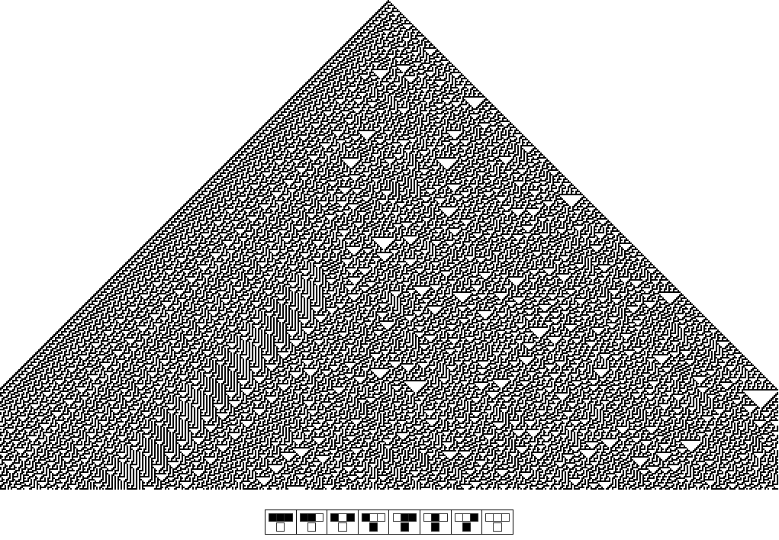

rule 30 cellular automaton

Next, we can move closer to the real world, with two examples that concern engineering, starting with robotics (Pickering 2002, 2004). The first style of building robots that comes to mind, the style dominant in computer science at least into the 1980s, is based upon symbolic AI. Drawing upon its artificial senses, within the robot a computer builds up a symbolic map of its environment and then uses that as the basis for computing how to achieve some predefined goal in the world—moving across a room without bumping into obstacles, say. Those computations are then translated into instructions to the robot’s motor organs and off it goes. The heart of this style of robotics is thus the computation entailed in mapping and processing maps, and this in turn can be seen as a nice piece of dualist ontological theatre. The robot’s world sits there passively, waiting to be represented by the robot; the robot has goals and reason; it is the only genuine agent around.

What interests me here is that there is a contrast class of robots which goes back to the beginnings of cybernetics. In 1948 Grey Walter built his first little robot ‘tortoises,’ autonomous machines that wandered through their environments in pursuit of light sources while bumping into and going round obstacles. The key point about this style of robotics is that it entailed no centralised mapping or computation—the tortoises simply reacted in real time to what they had found, scanning their worlds for lights, going into an oscillating motion when they hit obstructions and so on. Here then we have a style of robot-engineering that moves towards non-dualist ontological theatre—again both conjuring up the overall ontological vision and exemplifying a form of practice that takes advantage of rather than seeking to deny that vision. The robot’s performance depended on a sensitive back-and-forth between the robots’ travels and what they turned up in the environment; they lived in the thick of things rather than trying to escape from it.

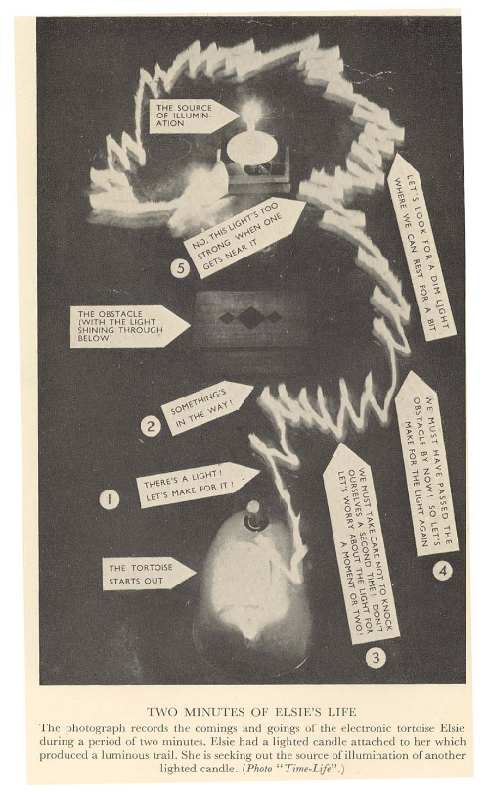

tortoise in action

Ross Ashby’s homeostat, also from 1948, took this sort of ontological theatre an important step further. The homeostat was a machine that randomly reconfigured its circuitry if its internal currents went beyond some given value. In some electrical environment, a homeostat would thus transform itself again and again until it found an equilibrium configuration in which its internal currents tended towards zero and stuck there in the face of perturbations. Importantly, Ashby experimented on multi-homeostat assemblages in which groups of homeostats constituted the environment for the others. These assemblages thus staged genuine dances of agency between all of their elements as the whole set-up searched randomly and open-endedly for equilibria, and again we can read them as non-dualist ontological theatre, both conjuring up a mangle-ish ontological vision—imagine the world as built from from homeostat-like entities—and playing that vision out constructively in robotics.

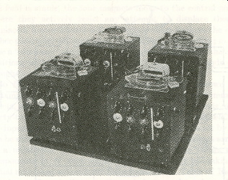

four interacting homeostats

Tortoises and homeostats are thus my next class of examples of projects, now in the realm of robotics, that occupy the space opened up by ontological reflections in science studies—they thematised and took advantage of a symmetric image of the world as a zone of intersection of performative agencies. And it is worth emphasising that such approaches to robotics have not gone away. The situated robotics that I associate with Rodney Brooks (1999) and the MIT AI Lab is a continuation of Walter’s robotics, and many of the problematics and insights of complexity theory relate rather directly to Ashby’s work with his homeostats. The original cybernetic robots were, actually, a key element in an unusual sort of brain science—a science that understood the brain as in the first instance an organ of performative adaptation rather than of representation and cognition—and the cybernetic approach is also returning to the forefront of contemporary brain science (Edelman 1992).

My next example of engineering is in the real world. Most large-scale civil engineering projects so obviously stage an asymmetric dualist ontology that we don’t even think about it. Civil engineering aims to reconfigure the environment to human ends. As I write, the New York Times reports on a new dam, said to be the largest ever in the world, designed to turn the Yangtze river into a massive source of electrical energy for the industrialisation of China (Yardley 2007). Again, and entirely typically, the material world figures here as a passive substrate awaiting the firm hand of human agency. And, again, it turns out there are other ways of going on, which stage the other sort of ontology. A field known as adaptive ecological management seeks to explore what nature ‘wants’ to do—via relatively small-scale performative trials such as experimental floods launched from dams and monitored for their downstream repercussions (Asplen forthcoming, Pickering forthcoming b). Again we have an image of a symmetric dance of agency: instead of imposing human plans from the outset, the idea is to tune our plans in the light of such experimentation and vice versa.

For the sake of variety, my remaining examples concern the arts, music and architecture. Gordon Pask’s Musicolour machine is the perfect example here—an inscrutable device with its own inner dynamics that turned a musical performance into a light-show, with which performers could establish a modus vivendi without ever reaching cognitive mastery—another staging of the dance of agency, this time in the arts and entertainment (Pickering 2006). But I have written about Musicolour too often, so let’s try Brian Eno instead. Eno himself acknowledges a debt to cybernetics going back to the 1970s, and much of his compositional work in ‘ambient’ and ‘generative’ music since then has consisted in exploring the generative possibilities of different sorts of algorithms, computerised or otherwise (Eno 1996a, b). Here we find a sort of dance of agency now in the ‘design’ phase in the arts, in which some CA-like set of rules figures symmetrically as a partner in the production of sound. Going further in the same direction, in some versions of this system of composition the user/listener also becomes to some extent the composer, being free to vary the parameters of the generative algorithm in a complex dance of agency entailing software engineers, the algorithm, Eno and the user herself. Once more then, and now in the arts, this form of music occupies the space opened up by an ontological reflection beginning in science studies. This is how one might do artistic production if one takes the ontology seriously and puts it into action, instead of carrying on with practices of dualist purification.

Finally, we could turn to architecture. In the early 1960s, the radical theatre producer Joan Littlewood conceived a plan for a building in London that became known as the Fun Palace. Cedric Price was the architect for the project and Gordon Pask became the head of the cybernetics committee for its design (Pickering 2006). The Fun Palace was intended as a sort of ‘university of the streets,’ open to the public and providing a ‘kit’ of all sorts of resources for all sorts of activities. In the present context, the important thing was that, through all sorts of engineering innovations, the Fun Palace could be reconfigured in use. Pask understood it on the model of his Musicolour machine—as a system that would both respond to its users and also ‘get bored’ with them, as a way of disturbing routiines and eliciting new modes of use. Again, we can read the Fun Palace as ontological theatre—staging dances of agency with its users and at the same time exemplifying what architecture might look like if one took the overall ontological vision seriously. The key point to note is that, in contrast to conventional architectural design, the designers of the Fun Palace did not pretend to know in advance what use would be made of it—that had to be found out in practice in a continual process of adaptation, and the business of the designers was to make the building as open-endedly adaptable as they could.

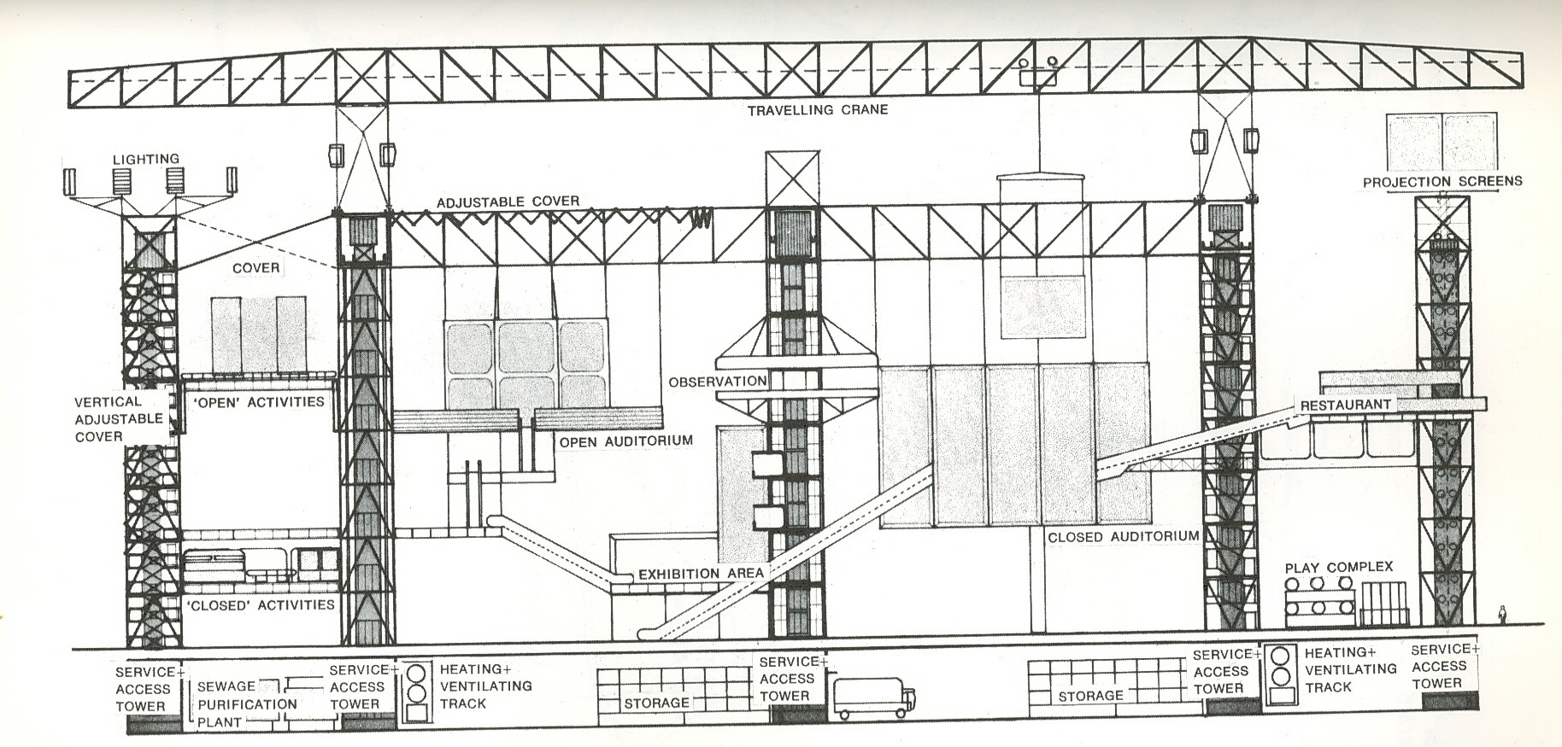

plan of the Fun Palace

•

As I said, we could carry on this list of examples almost endlessly, but I want to slow down and reflect on what is going on here. I started with some ontological reflections and the question of what might follow on from them for practice. I noted that Latour has answered this question in terms of representation (of people and things), and that I wanted to follow a different route, pointing to a class of projects that abstain from dualist purification and that instead thematise and take advantage of performative and open-ended dances of agency. But still, just what am I doing with this pointing? Latour has elaborated a relatively novel mechanics of representation, but I am just listing examples of what already exists. Where can that get us?

The first stage of an answer is to note that, with the possible exception of robotics, all of my examples point to projects that are relatively marginal to their fields; they somehow seem jokey and not quite proper. Wolfram finds himself trying to sustain his new kind of science outside the university departments of mathematics and science that might otherwise be their home. Cybernetic robotics was massively eclipsed by AI between the 1950s and 1980s at least. The US Army Corps of Engineers once more has the job of dominating the Mississippi River in the wake of Hurricane Katrina. The strand of ‘new music’ running from John Cage to Brian Eno was more visible in the 1960s than it is now. The Fun Palace was never built.

So the claim would have to be that an asymmetric dualist ontology holds not an absolute but a hegemonic sway over all the fields of endeavour that I have mentioned and many others as well, and that this is part and parcel of its being our natural ontological attitude. to borrow Arthur Fine’s phrase. And what I am trying to do here is to assemble another culture, to produce another world by drawing together and setting in relation to one another all sorts of elements that share a mangle-ish ontology and that lurk in the shadows of this hegemonic bloc. The hope is that if one puts enough of these elements together it will encourage one of those Kuhnian gestalt switches. We might suddenly get the hang of thinking about the world in non-dualist terms and, more important than just getting the idea of it, we might grasp that there are an indefinite number of ways to stage a non-dualist ontology in the future. I am trying to elicit a gestalt switch that would challenge the hegemony of ontological dualism in practice as well as thought, and this, of course, is where I part company with Latour.

•

Some elaboration of this point might be useful. Philosophical critiques of dualism in its many guises are ten-a-penny. We all know several versions. But they tend to remain toothless and trapped in the realm of ideas. Why might that be? It might be because non-dualist ideas find so little purchase in the made-world of our culture, the culture we have already assembled and find ourselves plunged into. We live in a world of objects and projects that continually echo back to us the truth of asymmetric dualism: a world of free-standing machines and technologies that stand apart from us, instantiating a kind of practical dualism of people and things; a built environment superimposed on nature—the street plans of whole cities laid out on a Cartesian grid; plane travel though structureless space, measured only as the flow of a linear time; social relations made predictable and computable through massive databases. This list, too, could go on and on.

The cultural assemblage we inhabit, then, forms our imagination—in this assemblage, it would be surprising if asymmetric dualism were not the natural ontological attitude, informing our grasp of both the world we live in now and how we can imagine transforming it. But, as I said, this assemblage is hegemonic not all-encompassing. The gestalt switch I would like to elicit aims to assemble a different constellation of real-world objects and projects in which a non-dualist imagination could nourish itself and grow in symbiosis with an evolving world of cultural production.

•

But still: why bother? A simple answer is: variety is good. The more ways we have of thinking about and acting in the world the better. Another is what Latour (1993) called the return of the repressed. The unintended and ecologically disastrous consequences of that dam on the Yangtze are already making themselves felt (Yardley 2007). It begins to be imaginable that the dark side of ontological purification is natural and social disaster: we pin nature down in one place and it bursts out on us somewhere else where we weren’t expecting it. I think that’s right. But here I want to focus on a more complicated answer to the why bother? question. This has to do with systematic differences between dualist and the non-dualist projects I have mentioned, and it helps me, at least, to think about Heidegger here.

In ‘The Question Concerning Technology,’ Heidegger (1997) conjured up an image of the contemporary world as characterised by a project that he called ‘enframing’—somehow setting up the world as a stock of ‘standing reserve’ for preconceived human projects. Heidegger saw technology and engineering as the key locus of enframing and the sciences as constructing the technical infrastructure for this stance. I think he was right, at least to a first approximation. Asymmetric dualism, as I have been calling it, is a highly appropriate ontology for enframing, and vice versa. But by describing the dominance of dualism as hegemonic rather than absolute, I want to suggest that Heidegger missed a trick here. As I have been trying to show, there are other scientific and mathematical and technological and artistic, and etc, ways to go on that do not stage any sort of dualist theatre, and we do not have to go back to ancient Greece to find them—we just have to look in the shadows of our own recent past and present. And, importantly, these other ways of going on are better characterised not as forms of enframing but of ‘revealing.’ None of the examples I reviewed speak of an asymmetric domination of the world through knowledge; all of them speak instead of an openness to what the world has to offer us, for better or for worse. One cannot imagine dominating and controlling a computationally irreducible cellular automaton—one just has to see what it does and try to get along with that. Ashby’s homeostats played with their own inner dynamics for the sake of exploring the dynamics of their environments. Adaptive environmental management explicitly renounces fantasies of domination in favour of exploring what the world wants to do, given the chance. Eno’s generative music is all about finding out what the algorithms and CAs will offer us (and not dictating a sequence of notes to a violin). The Fun Palace was an adaptive space in which to explore what people are like.

So now the political valence of this essay might be clearer. We can see this contrast between two ways of thinking about and acting in the world in terms of the contrast between enframing and revealing. Grim and, it seems to me, increasingly desperate and fraught, projects of dominating nature and humanity on the one hand; lively and responsive explorations of whatever surprises people and things have to offer us on the other. Given the choice, I know which one I’d pick. Part of the message of this essay is precisely that we do indeed have this choice and there are other ways to go on—something which is hard even to imagine when we are plunged into so many enormous dualist assemblages all of which echo a dualist ontology back to us. Latour wants to soften the sharp edges of these assemblages; I think we can inhabit different ones, which will echo back a different ontological story.

•

I need to qualify what I just said about picking and choosing. Is it my argument that the last few centuries of Western history were just a mistake and that we should just abandon their heritage? No. It can hardly be the moral of science studies that the dualist sciences from which we learned our ontological lesson should be exterminated. My idea is more that a gestalt switch between the margins and the hegemonic centre of gravity would be a way of putting dualist ontology and its associated projects in their place. If we could accomplish this change of perspective and stance in the world we could both see the world as I think it actually is, and see the dualist ontology and all its works for what they actually are: manifestations of a very specific and counter-intuitive stance in the world. If we retain asymmetric dualism as our natural ontological attitude we have little if any prospect of escape from the world of enframing. If we can get the hang of a symmetric non-dualism then we have the choice whether to indulge in enframing exercises or not. Especially, all those ‘unintended consequences’ of enframing, however well meant, come into sharp focus thanks to this gestalt switch. Unintended consequences are what we should expect—that’s the way world is—not something to be marginalised from our consciousness and blamed on the scientists and engineers and politicians for their lack of omniscient foresight.

In one direction, this returns us to Latour’s Parliament of Things, where the basic idea is an institutionalised watching-out for unintended consequences. But in Latour’s vision, these unintended consequences are still the unintended consequences of the old projects of dualist purification. What I would like to add is the idea that there are other ways entirely of going on—that thrive on unintended consequences rather than reacting to them after the fact.

•

All concepts, all institutions, all practices that interfere with the progressive objectivization of Nature—incorporation into a black box—and simultaneously the subjectivization of Society—will be deemed harmful, dangerous and, quite simply, immoral.
Bruno Latour, We Have Never Been Modern (1993, 141).

Latour was not, I think, joking when he wrote those words. He meant them, and, in my experience, he was speaking for many people. This extraordinary and Orwellian quote is an outright, if completely unargued, condemnation of the sort of politics of theory that interests me, a strident refusal to entertain it. I am trying to find political hope in precisely a set of projects that resist the objectivization of nature and the subjectivization (horrible words) of society; Latour thinks they are harmful, dangerous and immoral. Are they? I should grasp this nettle, and end by exploring what is going on here.

At one level, the analysis is obvious. The marginal elements of my nondualist assemblage are just that, marginal, and, as I said earlier, somehow jokey, not entirely to be taken seriously. They are not to be put in the set of heroic Western cultural achievements. Pask’s Musicolour machine was not Michelangelo’s David. Eno’s generative music is not Mozart (or even Stairway to Heaven). The Fun Palace was referred to by its critics as the prime example of ‘anti-architecture’—not in the space of the great Western architectural tradition; we can talk about ‘anti-psychiatry’ in a minute—these condemnatory ‘antis’ are everywhere in the cultural assemblage I am trying to put together.

So admirers of the Western cultural canon and children of the Enlightenment like Latour are not likely to be enthusiastic about this non-dualist canon I am trying to create. So be it—and we begin to see that there is a price to be paid even for thinking about an escape from enframing: it puts us immediately beyond the pale of high culture.

But I may as well admit it gets worse. All we have so far is cultural revulsion; we haven’t quite got to the harm, danger and immorality yet. We need to go back to ontology and the other side of the Cartesian divide.

On the one side of Cartesian dualism we find the material world and animals understood as predictable machines; on the other, we find human beings understood as somehow special and different from nature. For Descartes, this specialness resided in the immaterial soul that linked man to God. Many of us no longer believe in immaterial souls (or God), but this notion of specialness has echoed down the centuries as a sort of characteristic human exceptionalism in philosophy, the social sciences and cultured discourse more generally. Even in naturalising and critical mode, one finds an endlessly repetitive discourse on what’s special about us: the soul, reason, representation, emotion, ideals, language, culture itself. And inevitably this discourse has a moral dimension. It has to do with how we should be; how we should live up to our specialness, whatever it is. And intrinsic to this morality is the Latourian condemnation of thought and action that threatens to destabilise its Cartesianism—‘he’s just an animal!’

So now we have located the problem. Understanding our ontological condition as a performative dance of agency with human and nonhuman others is precisely not to dwell on our specialness—it is to step outside the moralised space of human exceptionalism. Performative dances of agency are just as much what rocks and stones, stars and planets, the plants in my garden and our cat, do, as what we do. Human specialness goes out of focus in this other world that I would like to produce, putting us yet further beyond the pale. Not just bad taste is at stake but also the Enlightenment as one long morality play. No wonder Latour starts to sound like Big Brother.

There are many ways to respond to this observation. One would be to note that the elaboration of the discourses on human exceptionalism has cost us something we once cared about—our immortal souls—and left us with a stripped down vision of bundles of wants and rights devoid of most of what makes life worth living, a vision which, moreover, somehow hangs together rather nicely with a world of enframing. This I think is true. Another response would be that to deny ourselves any profound ontological specialness is not to embargo any discussion of how we differ from rocks, cactuses, cats and machines. It is to say that we should think about how our finite specialnesses engage with our non-specialness. This takes us back to where we started, with STS. In The Mangle of Practice I didn’t deny that scientific knowledge was interesting and important—I just tried to show that we can get to grips with it better by thinking about how it engages with and is transformed in performative dances of agency with the material world.

So to step outside the space of human exceptionalism is not necessarily to become a pig wallowing in a trough. But we have not yet plumbed the moral depths. My instances of other ways to go on thus far have all been pretty respectable ones—I deliberately started with maths and engineering: one is disposed to take them seriously. But my research into the history of cybernetics has taken me into all sorts of strange and unexpected and, in Latour’s terms, entirely disreputable places: weird Eastern spiritualities, magical powers, psychedelic drugs, flickering strobes, sensory deprivation tanks, altered states, you name it. To keep the story short, let me just touch on the thread of this story which circles around madness.

Michel Foucault (1988) has told the story of the madman as the moralised—demonised—other of the Enlightenment. The man bereft of reason who has lost his specialness and fallen across the Cartesian divide, who has become animal. Even today, the madman is deficient, at best to be restored to a semblance of specialness by the administration of drugs (a very peculiar manoeuvre ontologically).

Gregory Bateson, one of the founders of cybernetics, thought otherwise. Bateson’s idea was that schizophrenia in particular could be understood as a form of adaptation to the sort of communicational impasse that he called the double bind—a specific performative move in the dance of agency that is social interaction (Pickering forthcoming c). Furthermore—and now we approach the basis of of Latour’s condemnation, I think—Bateson thought that perhaps schizophrenia was not all bad. He analogised the double bind to the contradictory instructions given by the Zen master to his disciple, thus suggesting that psychosis might be a very confused form of enlightenment (in the Buddhist not the Western sense).

At stake here, then, are the limits of the self. The modern, Western, Enlightenment, self has limits. Beyond them is the animal other, having a strictly negative moral valency. But if one thinks of the world as an open-ended performative dance of agency, who knows how the self will show itself next? If the modern self is in need of policing and enframing—‘subjectivization’—well, we could imagine instead a self that is continually revealed, for better and for worse.

This, then, is where the problem lies. The symmetric ontology of STS opens up a space for selves that are not fully ‘subjectivized’ and not fully split off from their ‘objectivized’ human and nonhuman environment—that continually become in what necessarily appear to be odd ways—that don’t conform to the Cartesian/Latourian dualist telos. The mad really are frightening—out of control and not controllable. They can stand here for all of the odd figures, including the shaman, the guru and the Beats, that threaten ‘harm,’ that constitute a ‘danger’ to the ‘moral’ order of the contemporary world. These are the others that are forbidden entry to Latour’s politics of things.

This is as far as I can go with this line of thought, except to add that Bateson’s ideas about madness did not remain in the realm of ideas. In London in the late 1960s, at a place called Kingsley Hall, where Mahatma Gandhi once stayed, they were put into practice by Bateson’s friend, the psychiatrist R D Laing, and his colleagues. Kingsley Hall was a commune in which mad people and psychiatrists and others lived together more or less on a par (in contrast to the rigidly hierarchical social relations of the mental hospital). And interestingly, Kingsley Hall was thought of as a space of revealing, where, as Laing put it, the sane could learn to go mad from the mad, where new sorts of selves could emerge (an idea that also attached to the Fun Palace). Kingsley Hall, and the entire anti-psychiatry movement as it was called, were endlessly controversial, but I would like to include it too in my counter-hegemonic gestalt, as part of this other world that I would like to assemble, that emphasises becoming and possibility, now at the level of selves, rather than fixity.

One might question the morality of taking the mad seriously, and it certainly strikes me as dangerous. But living together with them and trying to help them in daily life and even to learn from them strikes me as far more admirable than trying to ‘normalise’ them by prescribing a few drugs. I doubt whether human exceptionalism occupies the moral high ground that Latour thinks he stands on.
references

Asplen, L. (forthcoming) ‘Acting in an Open-Ended World: Nature, Culture, and Becoming in Environmental Management,’ to appear in A. Pickering and K. Guzik (eds), The Mangle in Practice: Science, Society and Becoming (Durham, NC: Duke University Press).

Brooks, R. (1999) Cambrian Intelligence: The Early History of the New AI (Cambridge, MA: MIT Press).

Callon, M. and B. Latour (1981) ‘Unscrewing the Big Leviathan, or How Do Actors Macrostructure Reality?’, in K. D. Knorr-Cetina and A. V. Cicourel (eds), Advances in Social Theory and Methodology: Toward an Integration of Micro- and Macro-Sociologies (Boston: Routledge and Kegan Paul), 277-303.

Edelman, G. (1992) Bright Air, Brilliant Fire: On the Maatter of the Mind (New York: Basic Books).

Eno, B. (1996a) A Year with Swollen Appendices (London: Faber & Faber).

Eno, B. (1996b) ‘Generative Music,’ a talk delivered at the Imagination Conference, San Francisco, 8 June 1996. Reproduced in In Motion Magazine, www.inmotionmagazine.com/eno1.html.

Foucault, M. (1988) Madness and civilization: A History of insanity in the Age of Reason (New York: Vintage).

Haraway, D. (2004) ‘A Manifesto for Cyborgs: Science, Technology, and Socialist-Feminism in the 1980s,’ in Haraway, The Haraway Reader (New York: Routledge), pp. 7-45.

Hayles, N. K. (1999) How We Became Posthuman: Virtual Bodies in Cybernetics, Literature, and Informatics (Chicago: University of Chicago Press).

Heidegger, M. (1977 [1954]) ‘The Question Concerning Technology,’ in D. Krell (ed.), Martin Heidegger: Basic Writings (New York: Harper & Row), pp. 287-317.

Latour, B. (1993) We Have Never Been Modern (Cambridge, MA: Harvard University Press).

Latour, B. (2004) Politics of Nature: How to Bring the Sciences into Democracy (Cambridge, MA: Harvard University Press).

Pickering, A. (1995) The Mangle of Practice: Time, Agency, and Science (Chicago: University of Chicago Press).

Pickering, A. (2002) ‘Cybernetics and the Mangle: Ashby, Beer and Pask,’ Social Studies of Science, 32, 413-37.

Pickering, A. (2004) ‘Mit der Schildkröte gegen die Moderne: Gehirn, Technologie und Unterhaltung bei Grey Walter,’ transl. by G. Rossler, in H. Schmidgen, P. Geimer and S. Dierig (eds.), Kultur im Experiment (Berlin: Kulturverlag Kadmos, 200), pp. 102-119. In English: ‘The Tortoise against Modernity: Grey Walter, the Brain, Engineering and Entertainment,’ in Experimental Cultures: Configurations between Science, Art, and Technology, 1830-1950 (Berlin: Max Planck Institute for the History of Science, Berlin, preprint 213, 2002), pp. 109-22.

Pickering, A. (2006) ‘Ontologisches Theater: Gordon Pask, Kybernetik und die Künste’ [‘Science as Theatre: Gordon Pask, Cybernetics and the Arts’], in H. Schramm, L. Schwarte and J. Lazardzig (eds), Spektakuläre Experimente: Praktiken der Evidenzproduktion im 17. Jahrhundert (Berlin: de Gruyter), pp. 454-76. To appear with revisions in English in Cybernetics & Human Knowing.

Pickering, A. (forthcoming a) ‘After Dualism,’ to appear in the Proceedings of the Gulbenkian Foundation Conference on ‘Challenges to Dominant Modes of Knowledge: Dualism,’ SUNY Binghamton, 3-4 November 2006, edited by Aviv Bergman, Jean-Pierre Dupuy and Immanuel Wallerstein.

Pickering, A. (forthcoming b) ‘New Ontologies,’ to appear in A. Pickering and K. Guzik (eds), The Mangle in Practice: Science, Society and Becoming (Durham, NC: Duke University Press).

Pickering, A. (forthcoming c) ‘Cybernetics as Nomad Science,’ to appear in C. B. Jensen and K. Rödje (eds), Deleuzian Intersections in Science, Technology and Anthropology (Oxford: Berghahn Books).

Wolfram, S. (2002) A New Kind of Science (Champaign, IL: Wolfram Media Inc.).

Yardley, J. (2007) ‘Chinese Dam Projects Criticized for Their Human Costs,’ New York Times, 19 Nov 2007.

It seems appropriate to construct this essay in terms of a critical engagement with Latour since he has done more than anyone else to think through the politics of things systematically and practically. And this serves to bring to the fore the profound conservatism of Latour’s politics which I. at least, had hitherto overlooked. But it is worth noting I could also have set it up more constructively, as a substantive development of Haraway’s (1994) cyborg politics and Hayles’ (1999) related discussion of embodied posthumanism.
Latour is emphatically in favour of this telos of dualist purification. In a table setting out what is to be retained from the moderns he lists ‘final separation between objective nature and free society,’ and goes on to refer to ‘objects whose genesis must no longer be clandestine, but must be followed though and through, from the hot events that spawned the objects to the progressive cool-down that transforms them into essences of Nature or Society’ (1993, 135).
The fullest coverage is in an unpublished book manuscript, Sketches of Another Future: Cybernetics in Britain, 1940-2000, where I discuss examples ranging over psychiatry, brain science, robotics, biological computing, complexity theory, theoretical biology, management, politics, spirituality, the arts, music, architecture and education.
At the level of ideas, we can return to the notion of marginality. It seems to me that very much of our educational system (and not just in science and mathematics) consists in the transmission of asymmetric dualist understandings of people and things. I find it hard to think of any counter-examples in pre-university education, and precious few at the undergraduate or even graduate levels.
I thank Carol Steiner for this accusation.

